NON-CONFORMITY MANAGEMENT

Function: | Prepared by: | Reviewed by: | Approved by:
Department: | Quality Assurance | Systems and cybersecurity | Quality Assurance
Name: | Iván Pérez | David Pozo | Fernando Pozo
Signature:
Date:

Valid until: | 02/06/2028

DOCUMENT HISTORY
VERSION | CAUSES OF CHANGE | DATE of entry into force | REPLACE A (Code, Revision)
01 | Initial edition | 14/02/2024 | N/A
02 | Change in Spika's departments. Adaptation of the procedure to digital format | 02/06/2025 | PNT-004.01

Content
1. Target 4
2. Outreach 4
3. Responsibilities and Departments concerned 4
4. Definitions and Acronyms 5
5. Procedure 6
5.1. Introduction 6
5.2. Classification of non-conformities 6
5.3. Minor non-conformity 8
5.4. Major non-conformity 8
5.5. Critical non-conformity 8
5.6. Non-conformity management 8
5.7. Cancellation of non-conformities 10
6. Distribution of the Procedure 10
7. Annexes 11
8. Related documentation 11
9. Training 11
Non-conformity notification form template 13
Template list of non-conformities 14
Impact assessment form 15

- Target
The aim of this procedure is to define the methodology used by SPIKA Tech, hereinafter SPIKA, to carry out an adequate management of non-conformities, in order to ensure that all non-conformities are identified, notified, evaluated and investigated, documented and approved in an appropriate manner and by the applicable personnel. Likewise, to define and manage the implementation of corrective and preventive measures derived from non-conformities in order to avoid recurrences.

- Outreach
The scope of this procedure applies to all non-conformities occurring in SPIKA's quality system, which may lead to deficiencies in the quality of the products and processes carried out at SPIKA.

- Responsibilities and Departments concerned
It is the responsibility of any SPIKA employee to report non-conformities immediately.
It is the responsibility of those responsible for SPIKA to manage the non-conformities that apply to the areas according to this procedure and that corrective and preventive actions are implemented.
The responsible technician shall approve all non-conformities and participate in and facilitate investigations.
The departments concerned are listed in the table below:
Department | Applies
 | Yes | No
Address | ☒ | ☐
Environment | ☒ | ☐
Quality Assurance | ☒ | ☐
Systems and Cybersecurity | ☒ | ☐
Research and Development | ☒ | ☐
Marketing and Sales | ☒ | ☐
Management | ☒ | ☐

- Definitions and Acronyms
- Non-conformity: any unexpected departure from pre-established quality standards, variation from standard operating procedures, or any action during the course of a process that deviates from previously established guidelines in approved instructions, with the potential to affect product quality.
- Planned non-conformity: any non-conformity of a documented procedure deliberately carried out for a given period of time, in order to manage an unavoidable situation.
- Recurring non-conformity: A recurring non-conformity is when there is a repetition of an event over a consecutive 12-month period due to the same root cause.
- Root cause: is the final cause that if corrected would prevent recurrence of the event.
- Corrective action: action to eliminate the root cause of a detected non-conformity or other undesirable situation.
- Preventive action: action to eliminate the possible root cause of a potential non-conformity.
- Correction: action taken to eliminate the non-conforming condition of the affected product or system.
- Severity: is the measure of the potential consequence of a hazard.
- Effectiveness check: evaluation of the adequacy of a corrective or preventive action to eliminate the root cause of a deviation.
- SOP: Standard Operating Procedure
- CAPA: Corrective Action Preventive Action.
- NC: Non-conformity

- Procedure
  - Introduction
Non-conformity is understood as any departure from pre-established quality standards, variation from standard operating procedures or any action during the course of a process that deviates from the guidelines previously established in the approved instructions, with the capacity to affect the quality of the product.
Situations documented according to good documentation practices such as obvious corrections, notational errors or transcription errors or missing data when they can be retrieved from primary data are not considered as non-conformities.

  - Classification of non-conformities
Non-conformities are classified according to their criticality/risk level.
In order to determine the allocation of the level of risk associated with a non-conformity, the following aspects have to be assessed:
- Severity of the consequences of the event
- Probability of non-detection

Severity | 5 = The non-conformity affects a critical quality attribute or parameter.  3 = The non-conformity affects a non-critical quality attribute or parameter.  1 = Non-conformity affects product quality, but must be documented.
Probability of non-detection | 5 = No controls in place  3 = Only one level of detection  1 = More than one detection mechanism

Using these criteria, the following risk matrix is used to classify the level of risk and the type of non-conformity:
 |  | Probability of non-detection
 |  | 5 | 3 | 1
Severity | 5 | 25 | 15 | 5
 | 3 | 15 | 9 | 3
 | 1 | 5 | 3 | 1

Once the level of risk associated with the non-conformity has been determined, the non-conformity shall be classified as:
- Minor non-conformity
- Major non-conformity
- Critical non-conformity
The level of effort, formality and documentation to be generated will be a function of the level determined and proportional to the risk.
  - Minor non-conformity
These are events whose risk level is < 3 (green area). Minor events, unless they are recurrent, do not require a CAPA plan.
Such non-conformities must be closed within 30 days from the date of notification.

  - Major non-conformity
These are events for which the risk level obtained is > 3 and< 9 (orange zone). Non-conformities classified as major will require investigation of the root cause(s) and the establishment of a corrective and/or preventive action plan.
These non-conformities shall be closed within a recommended maximum period of 30 days from the date of notification.

  - Critical non-conformity
These are those events whose risk level obtained is > 9 (red zone). Non-conformities classified as critical shall require investigation of the root cause(s) and the establishment of a corrective and/or preventive action plan. Once classified as critical, they shall be immediately brought to the attention of the responsible technical manager/technician.
These non-conformities shall be closed within a recommended maximum period of less than 30 days from the date of notification.

  - Non-conformity management
- Phase I: identification and reporting.
- Any SPIKA employee can identify a potential non-conformity that may adversely affect product quality. It is vital that personnel immediately report the non-conformity to their superior.
- The Responsible Technician or person delegated by him/her must be informed within 24 hours of the non-conformity being detected.
- As much information as possible should be obtained on the spot.
- The person who has detected it must fill in the online form provided for this purpose, an example of which can be found in Annex 1.
- Phase II: Impact assessment. The technical department, which will take on the role of assessor, receives the notification and follows the next steps:
- Coding of the non-conformity as follows:
NC-XXX/YYY
Where:
XXX is a three-digit sequential number that identifies the number of the non-conformity.
YY corresponds to the two digits of the current year.
The numbering will be given by the technical D. or person delegated by him/her, who will keep a record of them in the excel List of Nonconformities following the template included in Annex 2.
- Impact assessment, where the assessor will answer the questions included in the form.
- Determine the level of risk, where the assessor will assign the score based on the severity and likelihood of non-detection of the reported situation.
- Initial classification of the non-conformity.
- Phase III: CAPA plan. Once the root causes have been determined in phase III, a corrective and preventive action plan (CAPA) must be established to reduce and avoid recurrences. This plan will be documented in the spaces determined for this purpose, and there must be a CAPA for each root cause detected. If the establishment of CAPAs is not considered necessary, it shall be justified in the conclusions section.
The description of the CAPA shall contain:
- CAPA number: this number will be provided by the Responsible Technician or person delegated by him/her, as established in the PNT-006 procedure.
- Type of action: indicate whether it is a corrective or preventive action.
- Related root cause: in this field indicate the root cause number according to what has been indicated in Phase III (e.g. root cause 1, 2, 3...).
- Description: include details of the action to be taken
- Name/department responsible for implementation
- Deadline for implementation
With regard to effectiveness testing, an assessment of the adequacy of a corrective or preventive action to eliminate the root cause of a non-conformity may be included in the CAPAs. These effectiveness checks are not a verification of the execution of the activities but evidence that the non-conformity has not recurred after the action has been implemented or even after a pre-defined time period has elapsed.
- Phase IV: Review, approval and closure: The review, approval and closure of the non-conformity will be managed in accordance with the CAPA plan generated, where the responsible parties, deadlines and closure criteria will be defined.

  - Cancellation of non-conformities
A non-conformity may be cancelled at any stage of the process, if during the course of the investigation it becomes apparent that an event or situation has been incorrectly classified as a non-conformity. In this case, it shall be indicated in the "status" section of the list of non-conformities, including the justification for cancellation.

- Distribution of the Procedure
Staff belonging to the departments listed in Section 3 (Responsibilities and Departments concerned) should be provided with a copy of this procedure. In addition, controlled copy no. 1 will be given to the Archives for archiving on paper.

Controlled copies to be issued:
No. Controlled copy | Departments
1 | Archive

- Annexes
NUMBER / REV. | TITLE
1/01 | Non-conformity notification form template
2/01 | Template list of non-conformities
3/01 | Impact assessment form

- Related documentation
Code | TITLE
MQ-01 | Quality Manual
PNT-006 | Management of corrective and preventive actions

- Training
This version requires the following training for the departments concerned as indicated in paragraph 3:

Mark with an X | Type of training
☒ | Theoretical (reading and understanding of the procedure)
☐ | Theoretical - Practical (If this option is selected, please contact the Technician in charge).

Annex 1_VERSION_02

Non-conformity notification form template
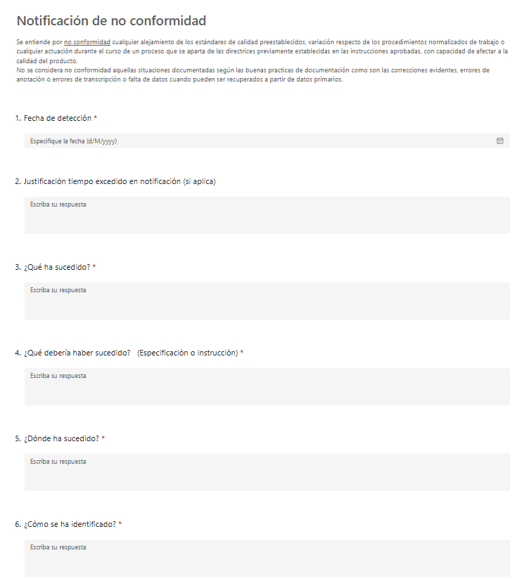

Annex 2_VERSION_02

Template list of non-conformities

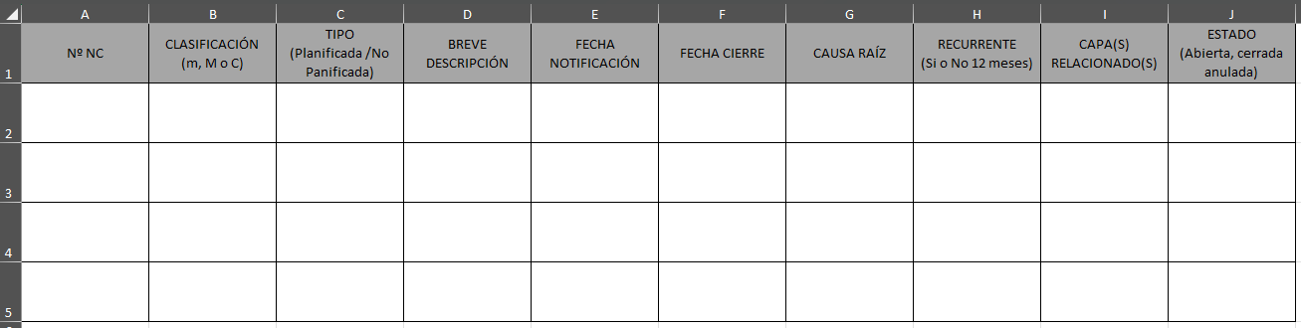

Annex 3_VERSION_02

Impact assessment form
PHASE II: IMPACT ASSESSMENT (to be completed by assessor) |  |  |  |  |  |  | Non-conformity code
Person who evaluates
Justification for the delay
(if applicable)
- QUALITY IMPACT ASSESSMENT
- Does non-compliance affect the... |  |  |  |  |  |  |  |  |  | YES |  | NO | N/A
- ...patient or user safety, arising from functionality, interface or alert failures? |  |  |  |  |  |  |  |  |  | ☐ |  | ☐ | ☐
- ...the validity or integrity of the clinical results generated by the software? |  |  |  |  |  |  |  |  |  | ☐ |  | ☐ | ☐
- ...the traceability of data, records or clinical records in the system? |  |  |  |  |  |  |  |  |  | ☐ |  | ☐ | ☐
- ...compliance with regulatory requirements (CE marking, MDR, FDA, etc.) or declarations to authorities? |  |  |  |  |  |  |  |  |  | ☐ |  | ☐ | ☐
- ...critical procedures (development requirements, testing, change control)? |  |  |  |  |  |  |  |  |  | ☐ |  | ☐ | ☐
- ...information security or cybersecurity (unauthorised access, integrity, confidentiality)? |  |  |  |  |  |  |  |  |  | ☐ |  | ☐ | ☐
- Is it a recurrent deviation? |  |  |  |  |  |  |  |  |  | ☐ |  | ☐ | ☐
- Does it require any immediate corrective action such as deactivation of functionalities, patches or temporary alerts? |  |  |  |  |  |  |  |  |  | ☐ |  | ☐ | ☐
- Has it caused complaints, clinical incidents, safety reports or software product recalls? |  |  |  |  |  |  |  |  |  | ☐ |  | ☐ | ☐
- Could other versions, modules or environments (test, production, customers) also be affected? |  |  |  |  |  |  |  |  |  | ☐ |  | ☐ | ☐
- Have any early detection mechanisms failed (automated tests, validation, configuration checks, code review)? |  |  |  |  |  |  |  |  |  | ☐ |  | ☐ | ☐
Additional remarks
- DETERMINATION OF THE LEVEL OF RISK
For the determination and assignment of the level of risk, scores shall be given:
a) the severity of the consequences of the event
(b) the probability of non-detection of the event taking into account the following rating scale:

Risk factor | Severity | Probability of non-detection
Rating scale | 5 = The NON-COMPLIANCE affects a critical quality attribute or parameter.  3 = The NON-COMPLIANCE concerns a non-critical quality attribute or parameter.  1 = NON-COMPLIANCE does not affect product quality, but must be documented. | 5 = No controls in place  3 = Only one level of detection  1 = More than one detection mechanism
Score assigned
Justification
After scoring, the level of risk will be determined on the basis of the following matrix:

 |  | Probability of non-detection
 |  | 5 | 3 | 1
Severity | 5 | 25 | 15 | 5
 | 3 | 15 | 9 | 3
 | 1 | 5 | 3 | 1

- INITIAL CLASSIFICATION OF THE NON-CONFORMITY ACCORDING TO RISK LEVEL
☐ | Minor non-conformity |  | ☐ |  | Major non-conformity |  |  |  | ☐ | Critical non-conformity
Type of non-conformity |  | ☐ |  | Planned |  | ☐ |  | Unplanned
Is the level of risk accepted on the basis of these standard criteria? |  | ☐ |  | YES |  |  |  |  |  | If no, please justify:
 |  | ☐ |  | NO
Remarks:

Name, signature and date

